1. Problem Statement
Produce a symmetric numeric pattern or number pyramid based on user-specified rows using nested loops and basic validation.
2. Objectives
- Use nested for loops to print a clean number triangle.
- Validate that the input rows number is positive.
3. Algorithm
- Start.
- Read number of rows $n$.
- If $n≤0$, print error; else use a loop from $1$ to $n$ to print numbers sequentially per row.
- Stop.
4.Flowchart
[Start]
--> [Input number of rows 'n']
--> [Check: Is n <= 0?]
├── Yes --> [Print Error Message] --> [Stop]
└── No --> [Outer Loop: i from 1 to n]
--> [Inner Loop: j from 1 to i]
--> [Print Number j]
--> [Print Newline (\n)]
--> [End of Loops] --> [Stop]
5.pseudo code
START
PRINT "Enter number of rows:"
READ n
IF n <= 0 THEN
PRINT "Invalid input"
ELSE
FOR i = 1 TO n DO
FOR j = 1 TO i DO
PRINT j, " "
ENDFOR
PRINT newline
ENDFOR
ENDIF
STOP

6. Python Source Code
print("=== Numeric Pattern Generator ===")
rows = int(input("Enter the number of rows for the pattern: "))

if rows <= 0:
print("Error: Please enter a positive number greater than 0.")
else:
print("\nGenerating Pattern:\n")
# Outer loop for rows
for i in range(1, rows + 1):
# Inner loop for printing numbers in each row
for j in range(1, i + 1):
print(j, end=" ")
print() # Moves to the next line after each row
7. Test Cases & Output Log
- Test Case: Rows = 4 $→$ Output: Prints triangle of numbers 1 to 4.
- Log:
=== Numeric Pattern Generator ===
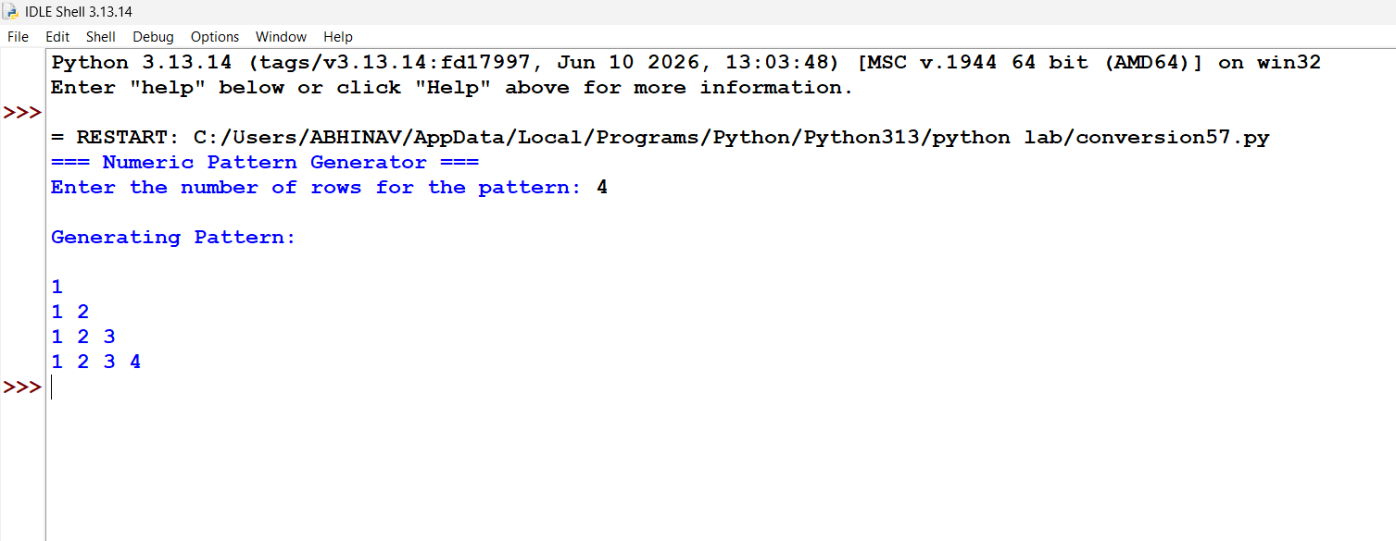

Conclusion: Successfully utilized nested loops and validation checks to dynamically generate structured numerical patterns and pyramids based on user-defined row counts.

